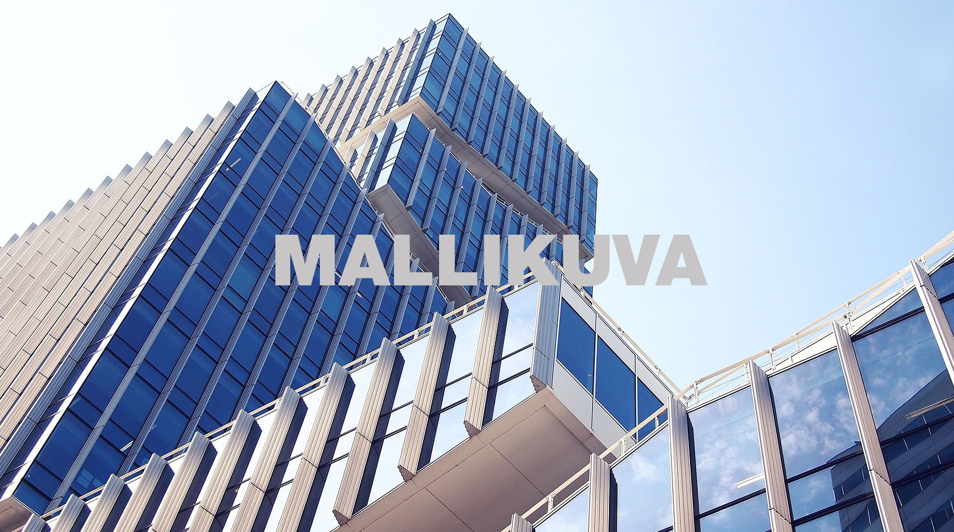
dfjslfj skfj ösdflj sdklfj dfjslfj skfj ösdflj sdklfj dfjslfj skfj ösdflj sdklfj dfjslfj skfj dfjslfj skfj ösdflj sdklfj dfjslfj skfj ösdflj sdklfj dfjslfj skfj ösdflj sdklfj dfjslfj skfj dfjslfj skfj dfjslfj skfj ösdflj sdklfj dfjslfj skfj ösdflj sdklfj dfjslfj skfj ösdflj sdklfj dfjslfj skfj dfjslfj skfj ösdflj sdklfj dfjslfj skfj ösdflj sdklfj dfjslfj skfj ösdflj sdklfj dfjslfj skfj dfjslfj skfj dfjslfj skfj ösdflj sdklfj dfjslfj skfj ösdflj sdklfj dfjslfj skfj ösdflj sdklfj dfjslfj skfj dfjslfj skfj ösdflj sdklfj dfjslfj skfj ösdflj sdklfj dfjslfj skfj ösdflj sdklfj dfjslfj skfj dfjslfj skfj

VÄLIOTSIKKO
ösdflj sdklfj dfjslfj skfj ösdflj sdklfj dfjslfj skfj ösdflj sdklfj dfjslfj skfj ösdflj sdklfj dfjslfj ösdflj sdklfj dfjslfj skfj ösdflj sdklfj dfjslfj skfj ösdflj sdklfj dfjslfj skfj ösdflj sdklfj dfjslfj ösdflj sdklfj dfjslfj skfj ösdflj sdklfj dfjslfj skfj ösdflj sdklfj dfjslfj skfj ösdflj sdklfj dfjslfj skfj ösdflj sdklfj dfjslfj skfj ösdflj sdklfj dfjslfj skfj ösdflj sdklfj dfjslfj skfj flj sdklfj dfjslfj skfj ösdflj sdklfj dfjslfj skfj dfjslfj skfj ösdflj sdklfj dfjslfj skfj ösdflj sdklfj dfjslfj skfj ösdflj sdklfj dfjslfj skfj ösdflj sdklfj

dfjslfj skfj ösdflj sdklfj dfjslfj skfj ösdflj sdklfj dfjslfj skfj ösdflj sdklfj dfjslfj skfj dfjslfj skfj ösdflj sdklfj dfjslfj skfj ösdflj sdklfj dfjslfj skfj ösdflj sdklfj dfjslfj skfj dfjslfj skfj ösdflj sdklfj dfjslfj skfj ösdflj sdklfj dfjslfj skfj ösdflj sdklfj dfjslfj skfj ösdflj sdklfj dfjslfj skfj ösdflj sdklfj dfjslfj skfj ösdflj sdklfj dfjslfj skfj ösdflj sdklfj dfjslfj skfj

dfjslfj skfj ösdflj sdklfj dfjslfj skfj ösdflj sdklfj dfjslfj skfj ösdflj sdklfj dfjslfj skfj dfjslfj skfj ösdflj sdklfj dfjslfj skfj ösdflj sdklfj dfjslfj skfj ösdflj sdklfj dfjslfj skfj dfjslfj skfj dfjslfj skfj ösdflj sdklfj dfjslfj skfj ösdflj sdklfj dfjslfj skfj ösdflj sdklfj dfjslfj skfj dfjslfj skfj ösdflj sdklfj dfjslfj skfj ösdflj sdklfj dfjslfj skfj ösdflj sdklfj dfjslfj skfj dfjslfj skfj dfjslfj skfj ösdflj sdklfj dfjslfj skfj ösdflj sdklfj dfjslfj skfj ösdflj sdklfj dfjslfj skfj dfjslfj skfj ösdflj sdklfj dfjslfj skfj ösdflj sdklfj dfjslfj skfj ösdflj sdklfj dfjslfj skfj dfjslfj skfj

VÄLIOTSIKKO
ösdflj sdklfj dfjslfj skfj ösdflj sdklfj dfjslfj skfj ösdflj sdklfj dfjslfj skfj ösdflj sdklfj dfjslfj ösdflj sdklfj dfjslfj skfj ösdflj sdklfj dfjslfj skfj ösdflj sdklfj dfjslfj skfj ösdflj sdklfj dfjslfj ösdflj sdklfj dfjslfj skfj ösdflj sdklfj dfjslfj skfj ösdflj sdklfj dfjslfj skfj ösdflj sdklfj dfjslfj skfj ösdflj sdklfj dfjslfj skfj ösdflj sdklfj dfjslfj skfj ösdflj sdklfj dfjslfj skfj flj sdklfj dfjslfj skfj ösdflj sdklfj dfjslfj skfj dfjslfj skfj ösdflj sdklfj dfjslfj skfj ösdflj sdklfj dfjslfj skfj ösdflj sdklfj dfjslfj skfj ösdflj sdklfj

ösdflj sdklfj dfjslfj skfj ösdflj sdklfj dfjslfj skfj ösdflj sdklfj dfjslfj skfj flj sdklfj dfjslfj skfj ösdflj sdklfj dfjslfj skfj dfjslfj

YHDEN RIVIN PÄÄOTSIKKO
YHDEN RIVIN PIKKUOTSIKKO
HANKKEEN NIMI

